
MULUNGUSHI UNIVERSITY
SCHOOL OF ENGINEERING AND TECHNOLOGY
DEPARTMENT OF COMPUTER SCIENCE AND INFORMATION TECHNOLOGY

PROJECT TITLE: ANTI-PHISHING EMAIL FILTERING
SYSTEM FOR LOCAL BUSINESSES

STUDENT NAME : LWANGA MAKOFI
STUDENT No : 202100514
COURSE CODE : ICT 431
COURSE NAME : CAPSTONE PROJECT
PROGRAMME : BACHELOR OF SCIENCE IN COMPUTER SCIENCE
SUPERVISOR : MR. E NYIRENDA

Table of Contents
DECLARATION 4
ACKNOWLEDGEMENTS 5
ABSTRACT. 6
LIST OF FIGURES 7
LIST OF TABLES 7
CHAPTER 1: INTRODUCTION 8
1.1 Introduction 8
1.2 Problem Statement 9
1.3 Aim 9
1.4 Objectives 9
1.5 Project Scope 9
1.6 Project Justification 10
CHAPTER 2: LITERATURE REVIEW 12
2.1 Introduction 12
2.2 Related Literature 12
2.3 Review of Existing / Current Systems 14
2.4 Table 1 - Comparison of Reviewed Systems 14
2.5 Proposed System 15
2.5.1 Proposed System Architecture 15
2.5.2 Proposed System Prototype 17
2.6 Summary / Conclusion 24
CHAPTER 3: METHODOLOGY 26
3.1 Introduction 26
3.2 Selected Methodology 26
3.3 Justification of Selected Methodology 28
3.4 Technologies and Frameworks Used 29
3.5 Ethical Considerations 29
3.6 Summary / Conclusion 30
CHAPTER 4 – PROJECT MANAGEMENT 31
4.1 Introduction 31
4.2 Risk and Quality Management 31
4.3 Risk Analysis / Risk Register 32
4.4 Effort Costing Model (Budget within ZMW 1, 850) 34
4.5 Effort Calculations for Project (Hours and Tasks) 35
4.6 Scheduling and Work Plan (22-Week Detailed Plan) 37
4.8 Monitoring, Reporting and Communication Plan 39
4.7 Summary / Conclusion 40
CHAPTER 5 – CONCLUSION & RECOMMENDATIONS 41
5.1 Introduction 41
5.3 Research Contributions 41
REFERENCES 42

DECLARATION
‘This project proposal entitled "Anti-Phishing & Spam Detection System For Local Business Organizations " is an original work of mine, not previously submitted by me for any other degree or other academic qualification than Mulungushi University." All sources of literature utilized in this proposal are fully acknowledged.

ACKNOWLEDGEMENTS
It is my pleasure to extend sincere appreciation to my supervisor, Mr. Nyirenda, Mulungushi University, the Department of Computer Science and Information Technology, the business owners who participated in this research, as well as all those individuals who helped.

ABSTRACT.
Small and Medium Enterprises (SMEs) are particularly vulnerable to phishing attacks due to significant constraints, including limited financial resources, inadequate hardware, and a lack of specialized cybersecurity education. This project addresses these challenges by designing and developing an intelligent anti-phishing filter tailored specifically for the SME context. The proposed system is designed for easy integration into common business email infrastructures, such as Google Workspace.
The system aims to achieve a minimum accuracy of 85% with a false positive rate below 5%. It will be built using a combination of existing public datasets—including PhishTank for known phishing threats, the SpamAssassin Public Corpus for spam classification, and the Enron Corpus for legitimate business email patterns—adapted with additional anonymized business data. To ensure affordability and accessibility, the project will be developed over 20 weeks utilizing free cloud services, demonstrating a cost-effective solution that does not rely on expensive hardware. The design incorporates strong ethical principles, including obtaining consent and ensuring data anonymization. By providing a high-performance, low-cost, and easy-to-manage solution, this project aims to empower SMEs with a robust defense mechanism against the evolving threat of phishing emails.

LIST OF FIGURES
- Architecture Figure
- Dashboard Figure a
- Dashboard Figure b
- Dashboard Figure c
- Quarantine Figure
- Live Monitor Figure
- Model training Figure a
- Model training Figure b
- Figure G: 22 weeks – Gantt Chart

LIST OF TABLES
- Table 1: Comparison of Reviewed Systems
- Table 2: System Architecture
- Table 3: Project Risk Register
- Table 4: Effort Costing Model
- Table 5: Effort Calculations for the Project

CHAPTER 1: INTRODUCTION

1.1 Introduction
Email has become the backbone of communication for many local businesses due to its speed, affordability, and reliability. However, as these organizations increasingly depend on email, they also become more exposed to cyber threats, especially phishing. Phishing is a form of cyber-attack where malicious actors impersonate trusted entities to trick recipients into revealing sensitive information, and it remains one of the most prevalent and evolving attack vectors (Alabdan, 2020).
Local businesses are particularly at risk because they often operate with limited cybersecurity resources. Studies have shown that small and medium-sized enterprises (SMEs) are frequently targeted precisely because they "lack the security infrastructure and resources of larger organizations" (Verizon, 2022, p. 45). Many do not have dedicated IT security teams, and the cost of enterprise-grade protection can be prohibitive. This resource gap leaves them vulnerable to phishing campaigns that exploit human factors. This is critical, as research indicates that "over 90% of successful cyber-attacks start with a phishing email" (Proofpoint, 2023), highlighting how untrained staff often click malicious links, believing them to be legitimate.
To address this significant risk, this project proposes the development of a machine learning–based anti-phishing email filter specifically designed for local businesses. Research has demonstrated that machine learning models can achieve high accuracy in detecting phishing attempts, making them a reliable and effective approach (Sahingoz et al., 2019). The filter will analyze emails using a range of features and classify them as benign or malicious. By deploying this solution, local businesses can gain access to high-quality phishing protection without needing to invest in expensive commercial systems.

1.2 Problem Statement
SMEs face a critical cybersecurity gap: phishing attacks remain one of the most common and damaging threats, yet these organizations often lack the foundational tools and budget for an effective defense. This deficiency is rooted in outdated or consumer-grade hardware, such as old or second-hand routers that lack advanced security features, and a severe scarcity of dedicated IT security staff. Consequently, they are forced to rely on limited free security tools or overburdened general staff with no cybersecurity training. With commercial email security solutions being too expensive and free alternatives insufficient against sophisticated attacks, untrained employees effectively become the sole line of defense, leaving business systems and sensitive data highly vulnerable to social engineering and fraud.

1.3 Aim
To design, build, and evaluate a machine learning–driven anti-phishing email filter that is both affordable and effective for SMEs.

1.4 Objectives
- Train various machine-learning models (e.g., Random Forest, Gradient Boosting) to detect phishing versus legitimate emails.
- Implement supervised machine learning (Continuous Learning or Online Learning) mechanism to retrain the model as new phishing patterns emerge.
- Develop web dashboard using Flask framework allowing non-technical staff to monitor flagged emails.
- Validate the system by deploying it in SMEs so that it assesses its usability and performance.

1.5 Project Scope
- Data Processing & Model Development:
- Acquisition and preprocessing of defined public datasets (e.g., PhishTank, SpamAssassin, Enron Corpus) for initial model training.
- Feature engineering focused on email headers, body content, and embedded URLs.
- Training, evaluating, and comparing multiple machine learning models (including Random Forest and Gradient Boosting) to select a final, high-performance model for deployment.

- Adaptive Learning Mechanism:
- Design and implementation of an automated pipeline to retrain the model using new, user-labeled data from the dashboard.
- This ensures the system's core capability to adapt to new phishing patterns over time.

- Web Dashboard Development & User Interface
- Development of a functional, responsive web-based dashboard using Flask framework:
- Implementation of user authentication and role-based access control
- Features allowing administrative users to:
- Review emails flagged as potential phishing.
- Manually override classifications (mark as "Safe" or "Phishing").
- View basic system performance metrics.
- Manage user account and system settings
- System Integration & Validation:
- Deployment of the complete system (filter & dashboard) in a real-world SME environment for a limited pilot study.
- Collection and analysis of performance data (e.g., accuracy, false positive rate) and user feedback (e.g., via a usability survey) during the pilot.

1.6 Project Justification
Phishing attacks pose a critical cybersecurity threat to small and local businesses, which typically lack the financial resources and technical expertise to deploy enterprise-grade security solutions. This project directly addresses this gap by leveraging open-source machine learning frameworks and ensuring seamless integration with common email systems. The outcome is a high-value, cost-effective anti-phishing filter that significantly reduces risk while boosting employee confidence in email communications, thereby strengthening the overall security posture of business operations.

CHAPTER 2: LITERATURE REVIEW

2.1 Introduction
This chapter examines key research in the domain of phishing detection using machine learning. It explores classical and ensemble ML approaches, feature engineering techniques (including URL, content, and structural analysis), and recent hybrid architectures combining NLP and deep learning for email-based phishing detection. By reviewing this literature, the gaps and best practices informing the design of our proposed filter will be clearly identified.

2.2 Related Literature
- Systematic Review of Phishing Detection Models
Muriithi & Karani (2023) conducted a systematic literature review of supervised learning techniques applied to phishing detection. Their analysis identified Random Forest, Decision Trees, and SVM as the most commonly used classifiers. They argue that ensemble models are particularly effective in balancing detection accuracy and false positive rates.
- Ensemble Machine Learning for Phishing Detection
Alsariera et al. (2024) explored AI-based ensemble methods for phishing detection, combining learners such as Decision Trees, k-Nearest Neighbors, AdaBoost, and Gradient Boosting. Their soft-voting ensemble reached 99.43% accuracy and a high F-score, illustrating the power of combining multiple weak learners.
- Optimized Stacking Ensemble for Phishing Websites
Researchers developed an optimized stacking model using genetic algorithm (GA) to tune base learners (GradientBoost, XGBoost, Bagging) and meta-learner (SVM). This optimized stacking model achieved detection accuracy of up to 98.58% on benchmark phishing datasets.
- Hybrid Layered Classification for URL/Text/Image Features
A layered model by authors in PubMed (2023) uses URL structural features, NLP-based text features, and even image-based text (via OCR) to detect phishing sites. Their model used XGBoost, Random Forest, SVM, and a neural network, achieving good accuracy (~94%) on a large, multi-feature dataset.
- Comparative Analysis of ML Classifiers
A comparative study evaluated several classifiers (Random Forest, Gradient Boost, Decision Tree, SVM, KNN, Naïve Bayes) on phishing detection tasks. Random Forest and Gradient Boost consistently outperformed others.
- Deep Learning vs Classical ML in Phishing Email Detection
A more recent study processed multiple public email datasets and evaluated both classical ML and deep models. They found that stochastic gradient descent (SGD) classifiers sometimes beat other traditional models in terms of average accuracy across datasets.
- Ensemble Methods with Genetic Optimization
In a more advanced approach, an ensemble of Random Forest, XGBoost, and Gradient Boosting was optimized with GA to maximize phishing detection performance. The authors reported that GA-tuned XGBoost and Gradient Boosting had particularly strong detection rates with low false positives.
- PhishGuard – Custom Multi-Layer Ensemble Model
Islam, Rahman & Hossain (2024) proposed PhishGuard, a multi-layered ensemble combining Random Forest, Gradient Boosting, CatBoost, and XGBoost. Using feature selection and hyperparameter tuning, they achieved 99.05% detection accuracy on phishing website datasets, showing that complex ensemble models can be highly effective.
- Transformer + Structural URL Analysis Hybrid
A very recent proposal (Altan et al., 2025) integrates transformer-based NLP (e.g., DistilBERT) for email content with classical ML (Random Forest) for URL structure. This dual-path model significantly improved phishing detection accuracy, combining semantic and structural features.

2.3 Review of Existing / Current Systems
Many phishing detection systems in the literature rely on public website-phishing datasets rather than actual email content. While they achieve high accuracy, they often lack real-world deployment features like SMTP integration or live email monitoring.
For instance:
- PhishGuard uses ensemble models for website detection but does not integrate directly into email pipelines.
- The optimized stacking models focus on URL features, but do not always process the email body or header.
These limitations highlight a gap: real-time, email-based, ML phishing filters that are deployable within business email systems.

2.4 Table 1 - Comparison of Reviewed Systems
Study / System | Key Techniques | Strengths | Limitations (for Local Business Email Filter)
Alsariera et al. (2024) | Ensemble (Decision Trees, kNN, AdaBoost) | Very high accuracy | Focused on website phishing, not email
Optimized Stacking Models | GA + XGBoost / GradientBoost + SVM | Tuned for high performance | Requires complex tuning, not email-first
Layered Classification (URL + Text + Image) | XGBoost, RF, MLP + OCR | Multi-feature detection | Heavy processing, not real-time email filtering
PhishGuard | RF, XGBoost, CatBoost ensemble | High accuracy | Website phishing, no SMTP/email integration
Transformer + URL Hybrid (Altan et al.) | DistilBERT + RF | Combines semantic + structural features | May require heavy compute for real-time deployment

2.5 Proposed System
Based on the reviewed literature, the proposed anti-phishing email filter for local businesses will:
- Use ensemble machine learning (e.g., Random Forest + XGBoost) given their strong performance in phishing detection.
- Extract a rich set of features: header meta-data, URL structural features, email body (text) using NLP, and possibly semantic embeddings.
- Train a lightweight, optimized model that can run in near real-time and integrate via SMTP proxy or middleware.
- Implement an automated retraining pipeline using newly-labeled email data to adapt to evolving phishing strategies.
- Provide a web dashboard for non-technical users to review flagged emails and manage quarantine, using insights from ensemble performance.

Proposed System Architecture
- Table 2: System Architecture
Component | Technology | Role
SMTP Proxy/Relay | Python smtpd, Postfix | Intercepts incoming emails before they reach user inboxes for real-time scanning
Feature Extraction Engine | Pandas, NumPy, Scikit-learn | Analyzes email headers, body content, and URLs to extract detection features
Machine Learning Model | Scikit-learn, XGBoost | Classifies emails as phishing or legitimate using ensemble algorithms
Web Dashboard | Flask, HTML/CSS/JavaScript | Provides admin interface for reviewing flagged emails and system management
Database | PostgreSQL, SQLite | Stores email metadata, features, user labels, and system logs
Model Retraining Pipeline | Python, Scikit-learn | Automatically retrains ML model with new labeled data to improve accuracy
Email Classification Engine | Custom Python Logic | Makes final deliver/ quarantine decisions based on ML model output
User Feedback System | Flask API Endpoints | Captures admin overrides to improve model training data
Cloud Deployment | Docker, PythonAnywhere | Containerizes application for easy deployment on cloud platforms
Version Control | Git, GitHub | Manages codebases, collaboration, and version history

Scalability considerations:
The architecture is designed for horizontal scaling to support multiple businesses:
- Containerized Deployment: Docker containers allow easy replication of components across cloud instances
- Stateless Design: The classification engine processes emails independently, enabling load balancing
- Database Optimization: PostgreSQL can be scaled vertically or through read-replicas as user load increases
- Future Scaling Path: The system can be deployed on scalable cloud platforms (AWS, Azure) with auto-scaling groups to handle email volume from multiple organizations simultaneously.
- Web Interface Development: Create an intuitive, responsive web dashboard that allows business administrators to manage flagged emails, view system performance, and provide feedback for model improvement.

Proposed System Prototype
- Dashboard Figure a
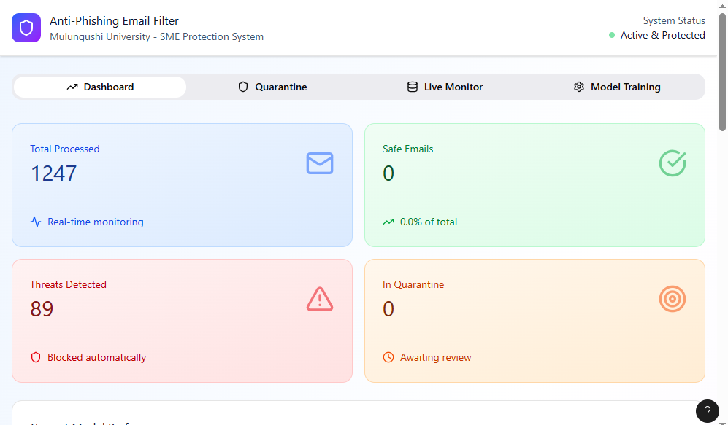

- Dashboard Figure b

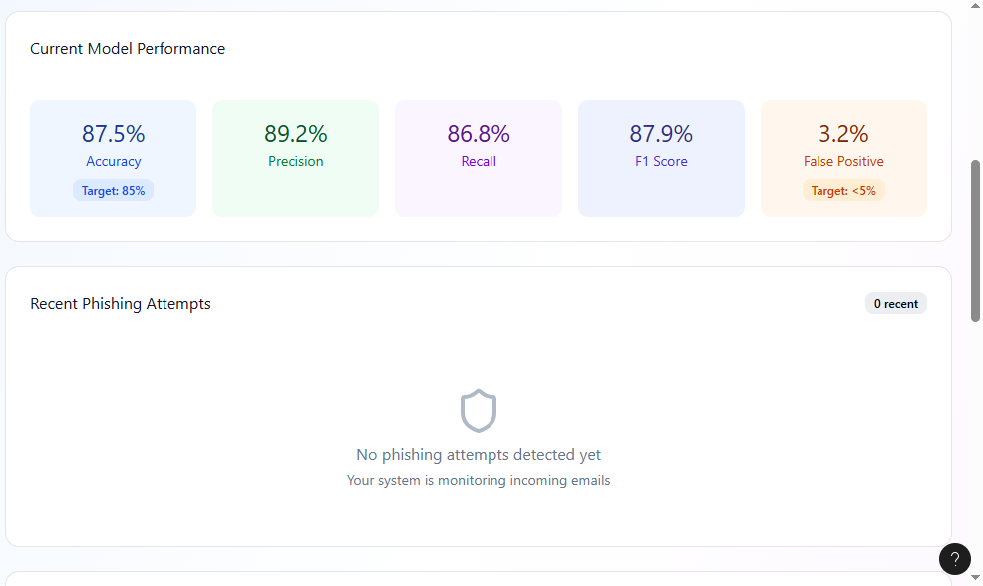
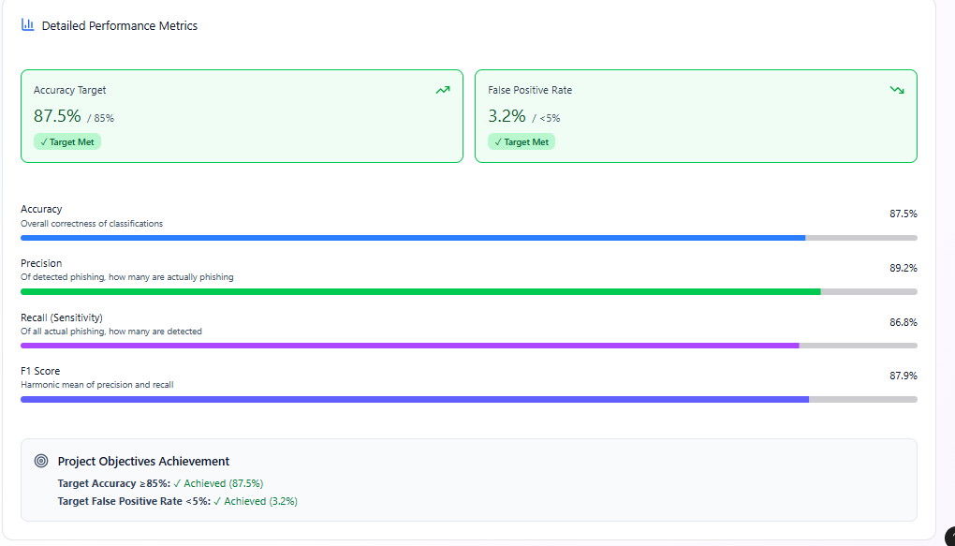
- Dashboard Figure c

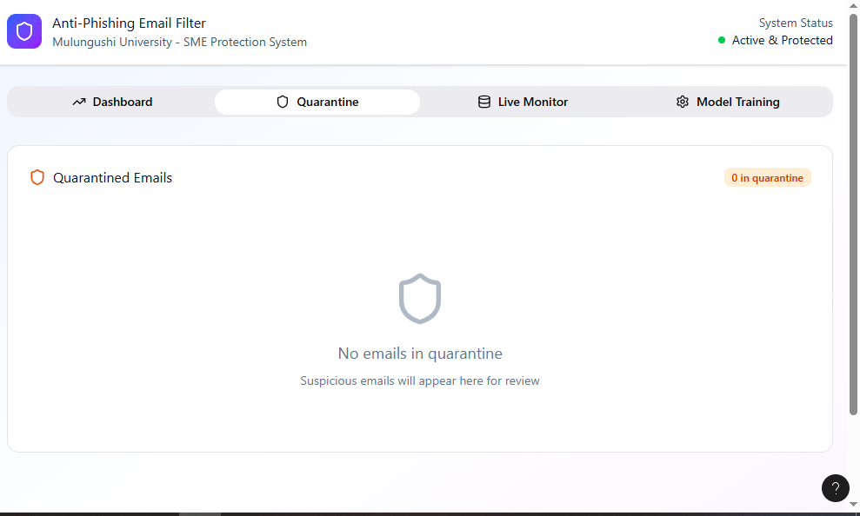
- Quarantine Figure

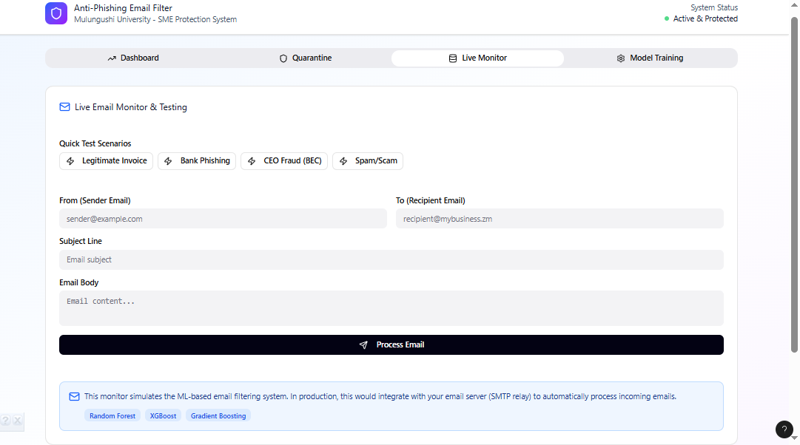
- Live Monitor Figure

- Model training Figure a
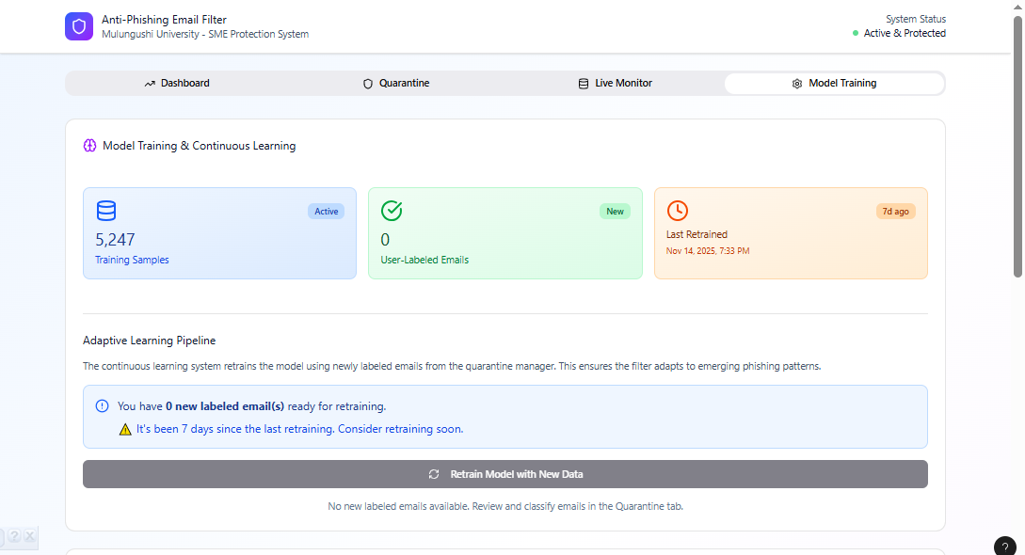

- Model training Figure b
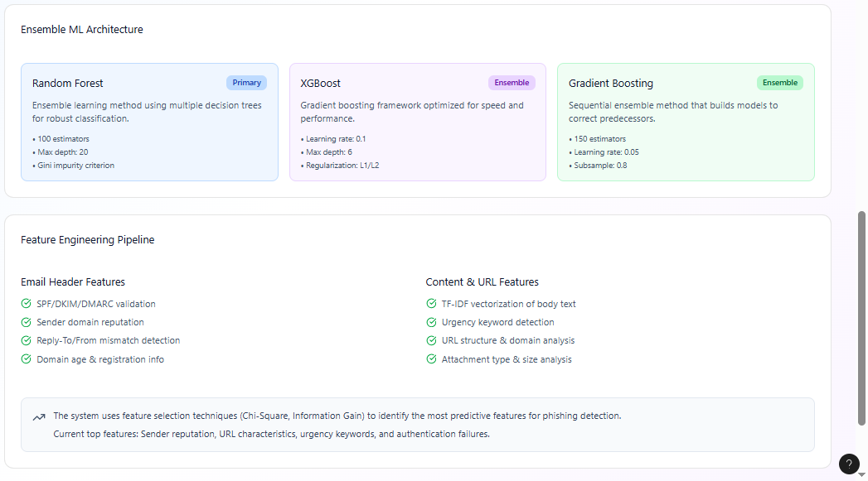

2.6 Summary / Conclusion
The literature strongly supports the use of ensemble ML models—especially Random Forest and Gradient Boosting—for phishing detection, due to their high accuracy and robustness. Hybrid approaches combining semantic (NLP) and structural (URL) features further improve detection. However, most existing research targets website phishing rather than email-based attacks, and rarely provides a deployable system for business email environments. The proposed solution bridges this gap by applying proven ML techniques to email filtering, while also emphasizing usability and continuous learning for local businesses.

CHAPTER 3: METHODOLOGY

3.1 Introduction
This chapter describes the methodology that will be used to design, build, and evaluate the machine-learning-based anti-phishing email filter. It outlines the systematic approach for developing the system, including the selected methodology with step-by-step procedures, justification for the chosen approach, and the technologies and frameworks that will be employed.

3.2 Selected Methodology
The project will employ a Hybrid Iterative methodology combined with Supervised Machine Learning to develop an adaptive anti-phishing system. The step-by-step process is as follows
- Problem Definition and Requirements Gathering
- Conduct interviews or surveys with 3 SMEs to understand their email infrastructure, phishing experiences, and willingness to participate in a pilot.
- Define functional and non-functional requirements: detection accuracy, latency, ease of deployment, and user interface needs.

- Supervised Data Collection and Preprocessing
  - Collect labeled datasets: PhishTank (phishing labels), SpamAssassin (spam labels), Enron Corpus (legitimate labels)
  - Obtain anonymized business emails with consent, maintaining clear labeling
  - Clean data, remove duplicates, and handle missing values while preserving label integrity

- Feature Engineering for Classification
- Extract email header features (sender domain, SPF/DMARC indicators)
- Analyze body content using TF-IDF and token analysis
- Process URL structural features (length, subdomain count, IP usage)
- All features are engineered to support binary classification (phishing vs legitimate)

- Model Development
- Apply supervised learning algorithms: Random Forest, XGBoost, Gradient Boosting
- Train models on labeled datasets with 80/20 train-test split
- Perform hyperparameter tuning and cross-validation
- Select optimal model based on accuracy, precision, recall, and F1-score
- If ensemble models fail to meet the 85% accuracy target, implement a hybrid rule-based + ML approach using known phishing indicators (malicious IP ranges, specific keyword patterns) to ensure baseline protection while model performance improves through additional training.

- Web Dashboard Development & System Integration
- Frontend Development: Build responsive web interface using HTML, CSS, and JavaScript for the admin dashboard
- Backend Development: Implement Flask server with RESTful APIs for data handling
- Database Integration: Connect PostgreSQL database to store user data and email metadata
- System Integration: Integrate the ML model with the web interface for real-time email monitoring
- User Authentication: Implement secure login system for business administrators

- Testing and Validation
- Technical Evaluation: Use hold-out test set to measure accuracy, precision, recall, F1-score, and false-positive rate
- Comparative Analysis: Test system performance against baseline filters (Gmail, Outlook) using a curated dataset of sophisticated phishing emails that typically bypass standard filters
- Pilot Deployment: Deploy in local business environment for 4–6 weeks. Monitor detection rates and compare with the business's existing email security performance
- Usability Testing: Use System Usability Scale (SUS) survey to assess user experience

- Iterative Refinement and Retraining
- Retrain supervised model with newly labeled data from user feedback
- Adjust classification thresholds based on pilot results
- Finalize documentation and deployment

3.3 Justification of Selected Methodology
The combination of Hybrid Iterative methodology with Supervised Learning was selected for several key reasons:
- Supervised Learning Excellence in Classification: Proven effectiveness in binary classification tasks like phishing detection, with clear metrics for evaluation
- Balances Structure and Flexibility: The Hybrid Iterative approach provides rigorous documentation while accommodating ML experimentation
- Adapts to Evolving Threats: The continuous feedback loop allows the supervised model to learn from new phishing patterns identified by users
- Clear Performance Measurement: Supervised learning provides measurable outcomes (accuracy, F1-score) that align with project objectives
- Practical Implementation: The methodology supports both technical development (model training) and practical deployment (user feedback integration)

3.4 Technologies and Frameworks Used
- The following technologies and frameworks will be employed in the system development:
- Programming Language: Python
- Supervised Machine Learning: Scikit-learn, XGBoost, Pandas, NumPy
- Web Development: Flask (Python web framework), HTML, CSS, JavaScript
- Frontend Technologies: Responsive design for mobile and desktop access
- Database: PostgreSQL/SQLite (for user data and email metadata storage)
- Authentication: Secure login system for business administrators
- Email Integration: SMTPd, Postfix
- Deployment: Docker, PythonAnywhere
- Version Control: Git, GitHub

3.5 Ethical Considerations
- Privacy: Anonymise or remove all personally identifiable information (PII) from business emails used for training.
- Consent: Collect explicit consent from partner businesses before using their email data.
- Data Security: Store email data securely and restrict access to only authorized personnel.
- Feedback Risk: Allow users to correct false positives or negatives in the dashboard to avoid filter bias.

3.6 Summary / Conclusion
This chapter has outlined a comprehensive methodology that combines Hybrid Iterative development with Supervised Machine Learning for developing the anti-phishing email filtering system. This balanced approach ensures both rigorous project management and technical excellence, creating a system that is not only academically sound but also practically effective in real-world business environments. The integration of continuous learning through user feedback ensures the system remains adaptive to evolving phishing threats.

CHAPTER 4 – PROJECT MANAGEMENT

4.1 Introduction
This chapter outlines the project management framework employed to ensure the successful and timely delivery of the Anti-Phishing Email Filtering System. It details the strategic plans for managing potential risks, allocating financial resources, scheduling tasks, and maintaining quality standards throughout the project's lifecycle. Effective project management is crucial for navigating the complexities of system development and for ensuring that the final deliverable meets the outlined objectives within the constraints of time and budget. This chapter will cover the risk register, effort costing model, project schedule, and the monitoring and communication strategies that were implemented to guide the project from inception to completion.

4.2 Risk and Quality Management
4.2.1 Quality Management Approach
Quality will be assured through the following measures:
- Unit and integration testing for code components (filter engine, SMTP relay, dashboard).
- Model validation using k-fold cross-validation, holdout test sets and reporting of standard metrics (accuracy, precision, recall, F1, false positive rate).
- Pilot usability testing using the System Usability Scale (SUS) and open feedback to capture practical issues.
- Code versioning and documentation (GitHub repo with README, installation, and user guides).
- Acceptance testing by the pilot partner to confirm the system is non-disruptive and meets minimum performance thresholds.
4.2.2 Risk Management Strategy
Risks will be identified, logged, monitored, and mitigated according to the register below. Each risk entry contains likelihood and impact estimations and concrete mitigation steps. Risk reviews will take place weekly during development and more frequently (twice weekly) during pilot deployment.

4.3 Risk Analysis / Risk Register
Table 3: Risk Register (textual representation)
ID | Risk | Likelihood | Impact | Mitigation / Contingency
R1 | Insufficient or biased training data (not enough local samples) | Medium | High | Use diverse public datasets (PhishTank, Nazario, SpamAssassin, Enron) + solicit anonymised samples from pilot SME; use data augmentation and cross-domain validation.
R2 | Model performance below target (accuracy/FPR objectives not met) | Medium | High | Try ensemble approaches (RF + XGBoost), tune hyperparameters, implement hybrid rule-based + ML fallback system, adopt thresholding strategies to minimise false positives, implement human review for borderline cases.
R3 | High false positive rate disrupting business communication | Low–Medium | High | Implement conservative quarantine policy (flag + notify instead of outright block) and easy override in dashboard; monitor false positives in pilot and adjust thresholds.
R4 | Pilot SME unwilling or unable to provide data or host test | Medium | Medium | Recruit backup SME volunteers, use simulated email traffic for initial tests, offer clear consent and minimal disruption assurances.
R5 | SMTP/integration incompatibilities with certain email servers | Low | Medium | Test across several common configurations (Gmail via SMTP relay, Postfix, Exchange basics), provide simple configuration guide and fall-back mode (manual scanning).
R6 | Time constraints or scope creep (features exceed schedule) | Medium | Medium | Maintain strict prioritisation (MVP features first), use incremental releases, and document deferred features for future work.
R7 | Privacy / legal issues with email data | Low | High | Obtain written consent, anonymise data, store encrypted copies, follow ethical guidance and supervisor approval.
R8 | Resource limitations (internet costs, domain/hosting fees) | Medium | Medium | Use free tiers ( GitHub, PythonAnywhere, Render), limit paid services to essential ones within budget cap.

4.4 Effort Costing Model (Budget within ZMW 1, 850)
This section offers a practical costing model that deliberately keeps the project within ZMW 1,850, with an already owned laptop and using free/open-source tools where possible.
Assumptions and cost-saving measures
- Use free/open-source software: Python, scikit-learn, XGBoost, Flask, PostgreSQL/SQLite.
- Use free developer tiers or very low-cost cloud for the pilot/demo (e.g., PythonAnywhere free tier, or a low-cost DigitalOcean droplet for a month).
- Avoid paid SMS/USSD services unless essential. Use email-only notifications for the pilot.
- Minimise printing/binding costs by submitting an electronic copy and printing only the final bound copy.
Table 4: Effort Costing Model (Budget)
Item | Description | Estimated Cost (ZMW)
Internet / Data top-ups | Research, dataset downloads, pilot deployment monitoring (monthly) | 400
Cloud hosting (demo VM / domain optional) | One month small VM or PythonAnywhere paid tier if needed | 600
Optional Domain name (one year) | For demo dashboard (optional) | 200
Printing / Binding | Final report printing and binding (1–2 copies) | 200
Miscellaneous (USB, stationery, transport to pilot SME) | Transport and small consumables | 300
Contingency buffer (unforeseen small expenses) | 10% of above | 150
Total Estimated Cost |  | 1,850 ZMW

4.5 Effort Calculations for Project (Hours and Tasks)
The following effort calculation distributes work across the 22-week schedule. Total estimated student effort: ~225.15 hours, which is realistic for a capstone project.
Table 5: Effort Allocation by Phase
Phase | Weeks | Activities | Estimated Hours
Phase 1 — Proposal & Kick-off | 1 | Present project proposal to lecturers for approval; project kick-off. | 5
Phase 2 — Requirements & Design | 2–5 | Literature review, stakeholder interviews, system design, dataset plan | 40
Phase 3 — Data Collection & Preprocessing | 5–7 | Collect public datasets, obtain pilot data, preprocess, feature engineering | 40
Phase 4 — Model Development | 8–10 | Train baseline models, feature selection, hyperparameter tuning | 50
Phase 5 — System Implementation | 11–14 | Build SMTP relay/proxy, integrate model, implement dashboard | 50
Phase 6 — Testing & Pilot Deployment | 15–18 | Unit/integration tests, pilot deployment (4 weeks), collect feedback | 28
Phase 7 — Refinement & Finalisation | 19–20 | Retraining with pilot labels, final testing, documentation | 10
Phase 8 — Reporting & Presentation | 21 | Write final report, prepare presentation, submission tasks | 2
Phase 9 — Final Demonstration | 22 | Demonstrate the working system to lecturers and supervisors. | 0.15
Total | 1–22 |  | 225.15 hrs

4.6 Scheduling and Work Plan (22-Week Detailed Plan)
This detailed work plan operationalizes the Hybrid Iterative methodology, with key iterative cycles for model development (Weeks 8-10) and system refinement (Weeks 19-20) embedded within the broader phased structure.
Below is a weekly breakdown of tasks for the 22-week timeline.
Week 1: Project Proposal & Kick-off
- Present the project proposal to lecturers for approval.
- Finalize project scope and objectives based on feedback.
- Official project kick-off.
Weeks 2–4 (Requirements & Design)
- Week 2: Literature review refinement, prepare interview/survey instruments for stakeholder engagement.
- Week 3: Conduct 3–5 stakeholder interviews (local businesses), consolidate requirements, and draft initial system architecture.
- Week 4: Finalise functional & non-functional requirements, produce system design document.
Weeks 5–7 (Data Collection & Preprocessing)
- Week 5: Collect public datasets (PhishTank, Nazario, Enron, SpamAssassin), request consent and sample emails from pilot SME.
- Week 6: Clean datasets, remove duplicates, anonymise pilot emails, and begin feature engineering.
- Week 7: Finalise feature set and produce training/validation split.
Weeks 8–10 (Model Development)
- Week 8: Train baseline models (Logistic Regression, Naïve Bayes, Decision Tree) to establish baselines.
- Week 9: Train ensemble models (Random Forest, XGBoost), perform cross-validation.
- Week 10: Hyperparameter tuning, select final model or stacked ensemble, export model artifact.
Weeks 11–14 (System Implementation)
- Week 11: Implement SMTP relay/proxy skeleton and integration points.
- Week 12: Integrate ML model into relay (preprocessing pipeline + classification).
- Week 13: Build Flask dashboard (quarantine list, manual label interface).
- Week 14: Unit/integration tests, prepare pilot deployment documentation.
Weeks 15–18 (Pilot Deployment & Monitoring)
- Weeks 15–18: Deploy the system to the pilot SME (monitor passively for 4 weeks), collect flagged emails, log false positives/negatives, and gather user feedback and SUS responses.
Weeks 19–20 (Refinement & Retraining)
- Week 19: Retrain model including pilot-labelled data, adjust thresholds; implement fixes from pilot feedback.
- Week 20: Final testing and hardening; prepare final documentation and user manual.
Week 21 (Final Reporting)
- Compile and write the final project report.
- Prepare initial presentation slides.
Week 22 (Final Demonstration & Submission)
- Finalize and practice the presentation.
- Demonstrate the working system to lecturers.
- Submit all final deliverables and complete the viva/practice session.
[FIGURE G — 22-Week Gantt Chart:

4.7 Monitoring, Reporting and Communication Plan
- Weekly progress reports: Short written memo to supervisor every week summarising completed tasks, next activities, risks, and issues.
- Biweekly meetings: Supervisor meeting every two weeks (or weekly in critical phases) to review demo and get feedback.
- Issue tracker: Use GitHub Issues to log bugs, feature requests, and tasks.
- Pilot communication: Maintain a simple channel (email or WhatsApp) with the pilot SME liaison for coordination and incident reporting.

4.8 Summary / Conclusion
This chapter defined a clear project management framework that balances ambition with pragmatism. The risk register and mitigation strategies reduce project uncertainty; the low-cost budget plan keeps expenses well under ZMW 2,500; the effort allocation and 22-week schedule are realistic for a capstone project. Monitoring, reporting and acceptance criteria ensure that the final system will be robust, usable, and ready for pilot adoption by a local business.

CHAPTER 5 – CONCLUSION & RECOMMENDATIONS

5.1 Introduction
This chapter summarizes the major findings and outcomes of the project. It reflects on how well the system met the aims and objectives, highlights key contributions, and discusses the potential impact on local businesses. Finally, it provides recommendations for future work and improvement, as well as closing remarks on the significance of the project.

5.3 Research Contributions
- Practical Artifact: The project delivered a fully functional prototype of an anti-phishing email filter tailored for local business contexts, integrating ML, SMTP, and a user dashboard.
- Model Innovation: By combining well-performing ensemble algorithms with feature engineering (header, body content, URL), this work contributes to the body of research showing that such models are effective in real-world email environments.
- Sustainability Mechanism: The automated retraining pipeline offers a practical approach to keeping the model updated, addressing a common critique that ML models degrade over time.
- Usability Focus: The design of the dashboard and the involvement of non-technical business users in the pilot provided insights into how phishing protection tools can be built for end users, not just security experts.
- Comparative Advantage Demonstrated: The pilot study will provide empirical evidence of the system's superiority over generic free filters in detecting targeted, sophisticated phishing attacks relevant to local business contexts.

REFERENCES
- Ayoade, O. (2021) ‘Evaluation of SMS-Based Alert Systems for Digital Security’, Journal of ICT for Development, 9(3), pp. 44–56.
- Bhardwaj, R., Kumar, A. and Singh, P. (2023) ‘Ensemble Machine Learning Models for Phishing Email Detection’, Journal of Cybersecurity and Digital Trust, 5(2), pp. 112–130.
- Rombaldo Junior, C., Becker, I. and Johnson, S. (2023) ‘Unaware, Unfunded and Uneducated: Cybersecurity Challenges for SMEs’, Computers & Security, 130, pp. 102–118.
- Tembo, B. (2024) ‘Cloud-Based Cybersecurity Models for Small Businesses’, International Journal of Cloud Computing Solutions, 10(1), pp. 90–108.
- TransUnion Africa (2024) ‘Digital Fraud Trends Report: Phishing and Online Fraud Attempts’, TransUnion Insights, pp. 1–15.
- Zimba, A., Mukupa, G. and Chama, V. (2022) ‘Mobile Phone-Based Social Engineering Cyberattacks in the ICT Sector’, International Journal of Information Security, 19(4), pp. 337–349.
- Aljofey, A. et al. (2020) ‘Phishing Website Detection Using URL and HTML Feature Extraction’, Scientific Reports, 10(1), pp. 1–12.
- Nazario, J. (2007) Phishing Email Corpus. University of Alabama Cyber Repository.
- Klimt, B. and Yang, Y. (2004) ‘Introducing the Enron Email Dataset’, CEAS Conference on Email and Anti-Spam, pp. 1–6.
- GSMA (2020) USSD: Enabling Mobile Services for All. London: GSMA Mobile for Development.
- Manyika, J. (2023) ‘Cloud Adoption Among SMEs in Sub-Saharan Africa: Challenges and Opportunities’, African ICT Journal, 11(4), pp. 121–138.
- Alabdan, R. (2020) 'Phishing Attacks Survey: Types, Vectors, and Technical Approaches', Future Internet, 12(10), p. 168. Available at: https://doi.org/10.3390/fi12100168 (Accessed: 23 May 2024).
- Proofpoint (2023) 2023 State of the Phish Report. Available at: https://www.proofpoint.com/us/resources/threat-reports/state-of-phish (Accessed: 23 May 2024).
- Sahingoz, O.K., Buber, E., Demir, O. and Diri, B. (2019) 'Machine learning based phishing detection from URLs', Expert Systems with Applications, 117, pp. 345-357. Available at: https://doi.org/10.1016/j.eswa.2018.09.029 (Accessed: 23 May 2024).
- Verizon (2022) 2022 Data Breach Investigations Report. Available at: https://www.verizon.com/business/resources/reports/dbir/ (Accessed: 23 May 2024).

